**A**

**PROJECT REPORT**

**ON**



**COMPARATIVE STUDY WIPRO LIMITED**

**MASTER OF** **BUSINESS ADMINISTRATION**

# (SESSION 2021-23)

TO

**MAHARSHI DAYANAND UNIVERSITY, ROHTAK**



**SUBMITTED BY :- DHEERAJ**

**02MBA21160**

**LETTER OF TRANSMITTAL**

**Date:25.11.2022**

**MAHARSHI DAYANAND UNIVERSITY**

**MDU CPAS GURUGRAM**

## **Subject:** Submission of Internship report on “Human Resource Management of Wipro private Limited”

Dear Sir,

With great pleasure I hereby submit my internship report on "HR practices of wipro private Limited." The report has been completed by the information that I gathered from the major courses on Human Resource Management which I have completed during my MBA as well as from my internship period in wipro private Limited.

As a requirement of preparing an internship report based on the practical knowledge in an organization, I selected **Recruitment** as my core concentration along with few other HR practices that I have come across during my internship program. I have tried my level best to complete this report meaningfully and correctly, as much as possible. I hope this report will reflect on the contemporary issues on the Human Resource Management that are being Practiced by this organizations in our country.

Thanking you.

Sincerely yours,

___________________

Dheeraj

Roll No :- 02MBA21160

**MDU CPAS GURUGRAM**

**MAHARSHI DAYANAND UNIVERSITY ROHTAK**

## **Acknowledgement**

I would like to thank **MDU** University for giving me the opportunity to do this internship. I would like to thank wipro private limited for letting me do the internship at their HR Division Head office. I’d like to thank Shamim Ehsanul Haque

Sir, my internship supervisor for guiding me with the completion of this report. I’d also like to thank Mr. Imam Rasul Mohammed, SAVP & DCIO, and Investment Manager & Md. For had Rahman from wipro Research & HR Division for keeping me under their supervision and provide me with all the necessary information which has helped me in the completion of this report. I would also like to thank all the officials of wipro HR Department for allowing me to be an internee at their organization and help with necessary information.

**Table of Contents**

|  |  |  |
| --- | --- | --- |
| **Serial No.** | **Content** | **Pg No.** |
|  | Executive Summary | 1 |
|  | **Chapter 1: Organization** |  |
| 1.1 | Introduction | 2 |
| 1.2 | Scope of the Report | 2 |
| 1.3 | Objective of the Report | 2 |
| 1.4 | Sources of Information | 3 |
| 1.5 | Limitations | 3 |
|  | **Chapter 2: Organization Profile** |  |
| 2.1 | Organization Background | 4 |
| 2.2 | Key facts about wipro | 4 |
| 2.3 | Organization Vision | 5 |
| 2.4 | Organization Mission | 5 |
| 2.5 | Goal of wipro | 5 |
| 2.6 | Values | 6 |
| 2.7 | Services | 6-7 |
| 2.8 | Strategic Objectives of wipro | 7 |
| 2.9 | Customer Charter | 7 |
| 2.10 | Organization Organogram | 8 |
| 2.11 | Organizational Structure | 9 |
|  | **Chapter 3: Overview of HR Division** |  |
| 3.1 | Human Resources Management | 10 |
| 3.2 | HR Function | 10-11 |
|  | **Chapter 4: HRM of wipro** |  |
| 4.1 | Units of HR Division | 14 |
| 4.1.1 | HR Staffing | 15-19 |
| 4.1.2 | HR Operations | 19 |
| 4.1.3 | Training & Development | 19-23 |
|  | **Chapter 5: Company Analysis** |  |
| 5.1 | SWOT Analysis | 24-27 |
| 6 | Findings and Recommendations | 28-29 |
| 7 | Conclusion | 30 |
| 8 | Reference | 80 |

### Executive Summary

During my internship I gained practical knowledge on how the human resource division of an organization operates and coordinates its activities to ensure smooth functioning of the organization at all levels by ensuring right numbers of people are available at the right time to do the right job. Not only that I have also gained insight into the working culture of the organization and observed how wipro private Limited handles its employees with value and empowerment to ensure they are motivated to give their best to the organization.

The report starts with an organization profile of wipro private Limited giving its background, mission, vision, its **products and services**, the hierarchy and organogram of the organization.

**The next section** is the comprises the project, Human Resource Management in wipro private Limited.

The project encompasses introduction to the topic, recruitment, selection, training and development.

Each chapter contains detailed discussion of the HR functions followed by Organization Practice at wipro private Limited which basically conveys how things are done in the HR Department.

The next part of the project carries out SWOT Analysis that touches upon strengths, weakness, opportunities and threats to the organization followed by findings and recommendation on critical factors regarding Human Resource Management of wipro. Finally there is the conclusion followed by references.

Chapter: 1

**Human Recourse Practices at wipro private Limited**

**Management Ltd**

#### 1.1 Introduction

I have select the topic of this report is “Human Resource Management of wipro”. I tried to integrate my theoretical knowledge of HR and combine it with practical examples as observed during my internship. I have tried to cover all the major functions of Human Resource Management- recruitment, selection, compensation and benefits, training and development and convey my understandings of the different functions of Human Resource Management through this project. At the end of the report I have done a SWOT Analysis on the HRM Practice of wipro followed by discussing critical points. I have also tried to provide some recommendations based on my knowledge followed by the conclusion which I gathered during my internship

#### 1.2 Scope of the Report

This report has been prepared through extensive discussion with company employees. Prospectus provided by the asset management company also helped in preparing the report. At the time of preparing the report, I had a great opportunity to have an in depth knowledge of all the investment activities practiced by the wipro private Limited.

#### 1.3 Objective of the Report

There have been some objectives set forward in doing this report so that it can be determined what tasks have to be done. The objectives of the report are:

* To familiarize with the wipro private Limited, its operation and activities, management style and endeavor to realized the gap between the theoretical knowledge with the real business world.
* Analyze the current performance appraisal format & compensation.
* Identifying inherent problems associated with the format.
* Propose changes mainly in the guidelines, format and management philosophy by keeping relevance with other processes.
* Employee Personnel practice.
* Developing Employees practices.

#### 1.4 Sources of information

All the information incorporated in this report has been collected from primary sources as well as secondary sources.

**Primary sources:**

* Interview with assistant manager of administration & HR-In Charge
* Operations manager and some other employees
* Discussion sessions with senior officers as well **Secondary Sources:**
* the wipro private Limited Asset Management Ltd Annual Report
* Job description for each employees of the wipro private Limited, HR Division.

|  |
| --- |
| * Performance appraisal format * Performance appraisal guideline provided by the Human Resources division   **1.5 Limitations**   * Limitation of employment personal. * Lack of practices in human resource management. * Human resources department was hesitant to provide information, because of difficulty in accessing sensitive data and information. * Non-availability of some previous statistical data. * The term of the internship period is brief time whereas Human Resources Division is a vast area, after doing the regular office works from 9:30 AM to 5:30 PM it is difficult to go through in depth within this short duration of time. * The secondary source of information was not enough to complete the report. * Confidentiality.   7 |

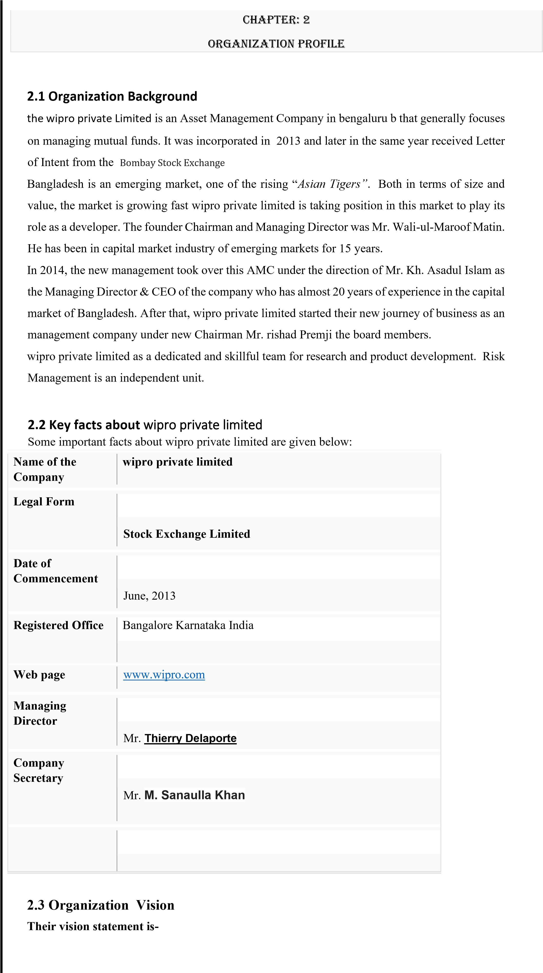

“Our vision is to establish wipro private Limited as the ultimate investment choice in Bangladesh. We want to develop a rich pool of research tools and strategies that will yield the best possible returns for our stakeholders and investors.”

##### 2.4 Organization Mission

**Its mission statement is-**

“Our mission is to give you the best possible return for your money and secure your financial future. We utilize only the best local talents available and comply completely with international norms and standards at every step of the way. Every decision made is completely transparent and undertaken with total professionalism. The interest of our stakeholders is our foremost concern.”

##### 2.5 Goal of wipro

The people, products and processes of wipro private Limited are associated to meet the demand of the judicious customers. Their goal is to achieve a distinction in the sky. Their Prime Objective is to deliver a quality that demonstrates a true reflection of our vision. This means they will give the best possible return for unit holders. And with that they will ensure financial growth for the organization, in the best wellbeing of their stakeholders.

##### 2.6 The Values

* Customer Focus
* Reliability
* Teamwork
* Respect for individual
* Quality
* Responsible Citizenship

##### 2.7 Services provide by Alliance Capital

* Mutual Fund
* Discretionary Portfolio Management

Mutual Fund is a mechanism for pooling the resources by issuing units to the investors and investing funds in securities in accordance with objectives as disclosed in offer document. wipro private Limited has wide experience and expertise of investment in securities primarily in equities in both these exchanges through Mutual Funds.

There are two types of mutual fund. They are:

1. Open-Ended Mutual Fund
2. Close-Ended Mutual Fund

**Open-End Mutual Fund**

wipro private Limited manages the open-ended fund of MTB Unit Fund. The holders of the shares in the Fund can resell them to the issuing Mutual Fund Company at the time. They receive in turn the net assets value (NAV) of the shares at the time of re-sale

**Closed-Ended Mutual Fund**

A closed–end Fund is open for sale to investors for a specific period, after which further sales are closed. Any further transaction for buying the units or repurchasing them, Happen in the secondary markets, where closed end Funds are listed. Therefore new investors buy from the existing investors, and existing investors can liquidate their units by selling them to other willing buyers.

**Discretionary Portfolio Management**

The art and science of making decisions about investment mix and policy, matching investments to objectives, asset allocation for individuals and institutions, and balancing risk against performance

##### 2.8 Strategic objectives of wipro private Limited

* wipro private Limited objectives are to carry out transparent and high quality [business op](http://www.assignmentpoint.com/business/finance/business-taxation-in-bangladesh.html)eration based on market mechanism within the legal and social framework spelt in their mission and reflected in their vision.
* Their greatest with qualitative business as a sustainable ever growing organization and enhance fair returns to their shareholders.
* They are committed to their community as a corporate citizen and contributing towards the progress of the nation as their corporate social responsibility.
* Their employees are the backbone. wipro private Limited romote employees well being through attractive compensation package, promoting staff morale through training, development and career planning.
* wipro private Limited strive for fulfillment of their responsibility to the government through paying entire range of taxes and duties and abiding the other rules.

##### 2.9 Customer Charter

wipro seek to build long-term, sustainable beneficial relationship with all the customers based on the service-commitments and on their underlying values of mutual respect, the pursuit of excellence and integrity in all their dealings.

* Primary concern is to understand and satisfy customer’s needs and expectations. Promise to use all means open to establish and understand these needs which are both mutually beneficial and respect the values and principles in all aspects.
* Promise to deal quickly, courteously and accurately with all correspondence.
* Should disagreement arise between customer and company they undertake to seek a speedy and equitable solution, which takes account of the rights and obligations, both parties and is framed in the context of a long term and enduring relationship.
* Believe in openness, integrity, transparency and accountability and provide high standard of services to the valued customers.

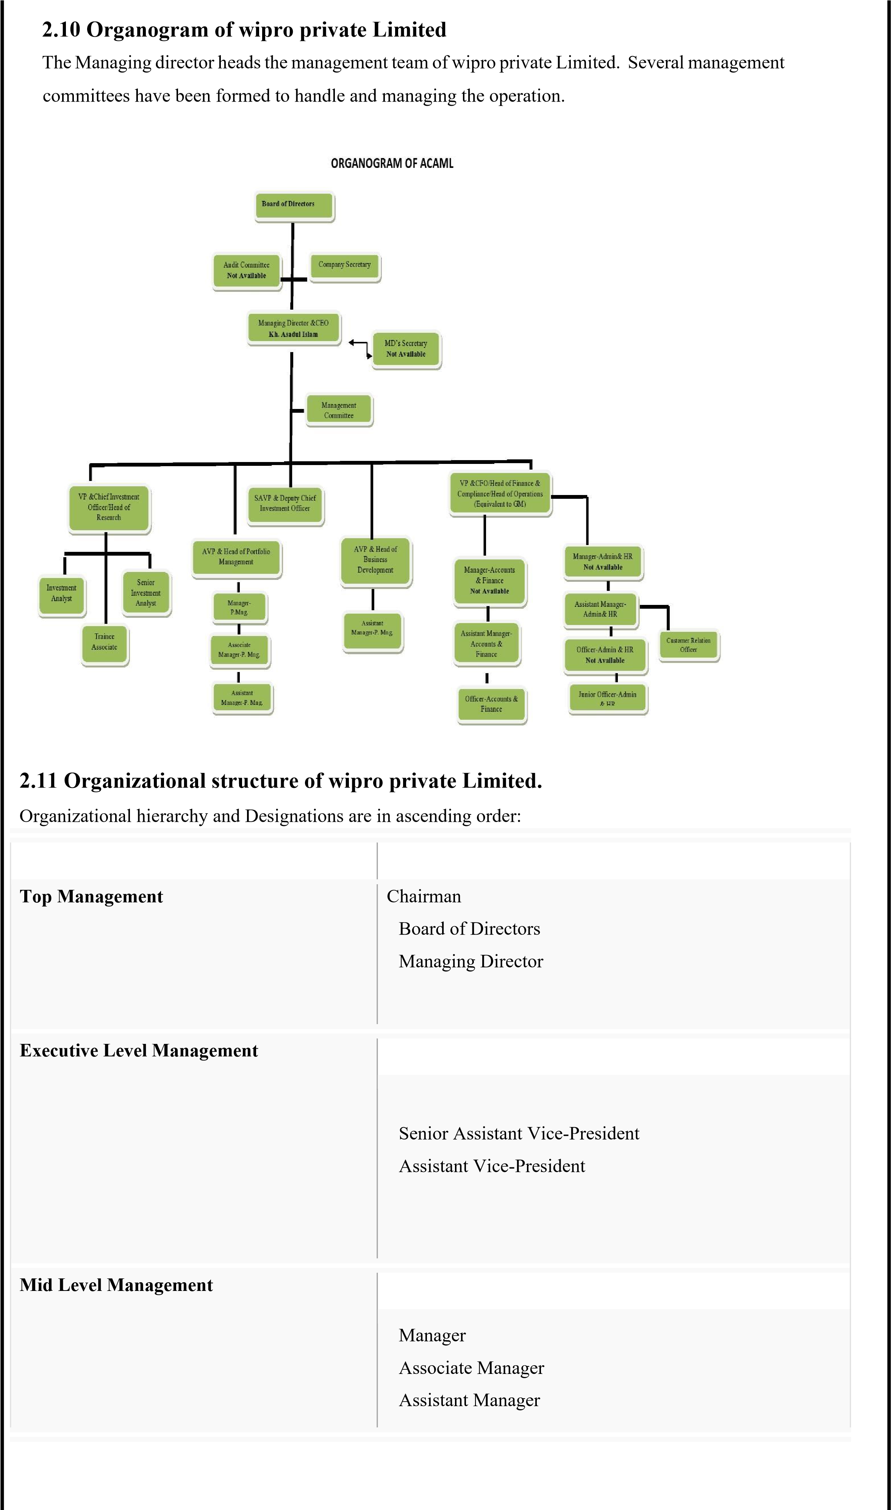

|  |  |
| --- | --- |
| **Junior Level Management** |  |
| Officer  Junior Officer  Trainee assistant  Probationary Officer |

Chapter: 3

Overview of HR Division

##### 3.1 Human Resources Management

Human resource management involves all management decisions and practices that directly affect or influence the people, or human resources, who work for the organization. In modern years, amplified concentration has been devoted to how organizations manage Human Resources. This augmented focus comes from the comprehension that an organization’s employees facilitate an organization to attain its goals and the management of these

human resources is vital to an organization’s success.

##### 3.2 Functions of HR

The functions of human resource management are:

1. Staffing
2. Training and Development
3. Motivation
4. Maintenance.

By doing all these functions Human resource management complete its job.

**Staffing in HRM**

Activities in HRM concerned with seeking and hiring qualified employees is Staffing. A company needs a well-defined reason for needing individuals who posses specific skills, knowledge and abilities to specify the job. Employee referrals can produce the best applicants for two reasons. First, current employees screen applicants before referring them. Second, current employees believe that their reputations with the firm will be reflected in the candidates that they recommend. Recruiting is the initial step of staffing. Recruiting is the process of locating, identifying, and attracting capable employees. Many companies are finding new employees on the World Wide Web. The source that is used should reflect the local labor market, the type or level of position, and the size of the organization. Now the second step of Staffing, that is Strategic HR planning. For that a company plans strategically. They set goals and objectives, these goals and objectives may lead to the structural changes in the company.

Third step is Selection. This process is attracting qualified applicators and discouraging the unqualified applicants. By this a company can get its desired employees of requirement. It has dual focus, attempting thin out the large set of applications that arrived during the recruiting phase and to select an applicant who will be successful on the job.

To achieve this goal, companies can use a variety of steps. The employees who are able to do all the steps and ensure good performance they get the job. HRM must communicate a variety of information to the applicants, such as the organization culture.

Under the selection process there are some steps:

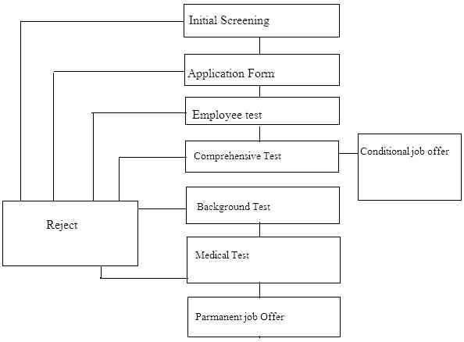

The company can use these steps to select the employees. With this process their Staffing job is done. The completed selection process ends the staffing functions.  **Training and Development:**



Training is one of the important activities of human resource management. In the training process companies try to motivate and train the employees in a manner so that they can work more effectively in the future. Under the training process there are some steps they are given below:

**Employee Orientation:** Employee orientation provides new employees with the basic background information they need to perform their jobs satisfactorily.

Companies arrange an orientation program for the employees.

In an orientation program the employees should feel-

* feel welcome
* understand the organization in a broad sense
* be clear about what the firm expects in terms of work and behavior ✓ begin the process of socialization  **Employee Training:**

Thereis some process, method and techniques of employee training. A company follows the all the steps of training to provide the employees a good look on their work.

**Career Development**:

The career development stage is given below

* **Pre transition:** Is simply looking for a job and preparing oneself for a career.
* **Transition:** An individual is already having a job and developing oneself for future career or moving to another career.
* **Preferred area:** An individual prefers a specific sector of the career.
* **Early stage:** First 1-5 years of career is called early career.
* **Mid career:** 5-20 years after the career starts.
* **Late career:** Late career starts after 20 years of job life.
* **Retirement:** And finally after completing the stages of career and individual decides to retired.

### Motivation in HRM

Motivation is to inspire people to work, individuals in such as to produce best results. It is the willingness to exert high level of effort towards organizational goals, conditioned by the efforts and ability to satisfy some individual needs.

An important part of the retention of staff, reducing staff turnover and minimizing absenteeism at work is ensuring that staff are properly motivated. The wage should be increased, the facilities should be insured and social security should be confirmed. These are the types of common motivational ways.

Staff motivation is the cornerstone of open, flexible and caring management culture, which the Government aims to establish through HRM.

To put it into practice, **“open”** means not only to listen to staff suggestions and opinions, but also to empower staff, accept their constructive criticisms and use their suggestions. To be **“flexible”**, we may need to change the traditional ways of doing things. As far as staff motivation is concerned, the biggest challenge perhaps is to stop focusing on problems and the guilty party (police behavior) and start looking for those responsible for things gone right (coach behavior).

**“Caring”** calls for a human leader who would give emotional support to individuals and at the same time attend to the overall emotional needs of team members – which include treating them all in a fair and impartial manner.

Today’s employees want a respect that can be seen as involvedness in decision that will affect them. Listening to the employees is a way of Motivation. All the motivation functions focus on one primary goal, to have some competent and adapted employees with up-to-date skills, knowledge and abilities, exerting high energy levels.

### Maintenance of employees

To maintain the employees of a company must look after the employee-  **Health and Safety**:

For employees health and safety there HR policy need to be very clear to all staff so that they feel safe to work here. They can put their attention and productivity properly towards the task.

 **Communication:**

The communication between the employees and top level management should be clear and transparent. There should no gap between top level management and low level management.

 **Employee’s relation:**

Employees should be committed to their companies and the companies also should understand the needs and wants of the employees. In some companies employees and labors create labor union for better relationship among the workers and employees.

Chapter: 4

HRM of

wipro private Limited

During my internship i

was mainly assign in HR department.

wipro private Limited

always

determine what jobs need to be done, and how many and types of workers will be required.

So, establishing the structure of the asset management company assists in determining the skills,

kn

owledge and abilities of job holders. To ensure appropriate personnel are available to meet the

requirements set during the strategic planning process. It believes that the quality work comes from

quality workers who are well motivated and ready to take ch

allenge to provide better service.

**4.1**

**Units in HR division**

**:**

There are three units in Human Resource Division of Alliance Capital

-

✓

HR Staffing

✓

HR Operation

✓

Training & Development.

**4.1.1**

**HR Staffing**

**:**

The staffing process

-

putting the right people in the right positions at the right times

-

is one of the

most critical tasks any organization faces. The quality of the work performed can be only as high

as the capabilities of the people performing it.

Thre

e officers are working in HR staffing unit. They perform the following activities

-

i.

Recruitment ii. Selection iii. Leave Management iv. Personal Profile

Management

**Recruitment:**

Recruitment is the process by which

a firm finds its employees, are perhaps the most critical

tasks any organization faces. Without the right people, no firm can function effectively.

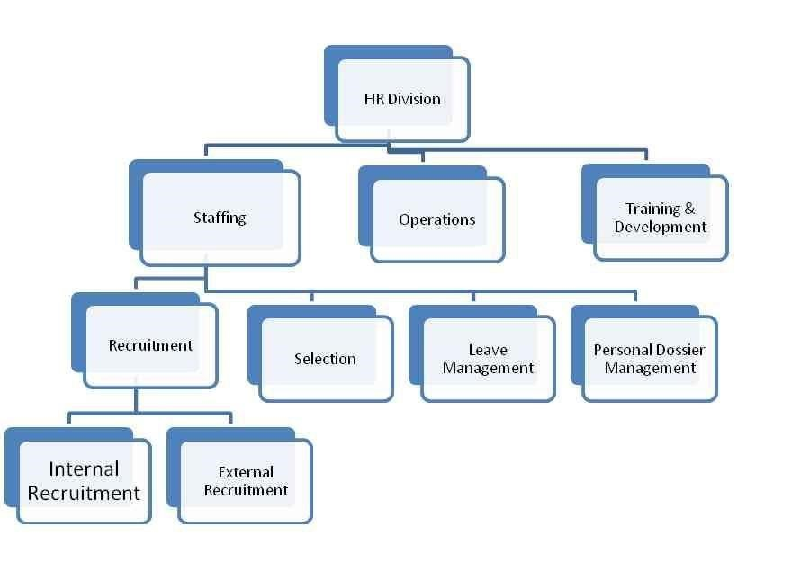

For a recruitment program to be successful, managers should cooperate with the human resources staff to define needs and predict vacancies.

This recruiting may be done by internal or external.

**Types of Recruitment:**

There are two types of recruitment in this organization. They are:

1. Internal Recruitment
2. External Recruitment.

✓ **For Internal Recruitment**: The principal methods are- ▪ Job posting

* Use of computerized skills inventories
* Referrals from other departments ✓ **For External Recruitment:**

Organizations rely on- ▪ Advertisements

* Public or private placement agencies
* Field recruiting
* Including campus recruiting **Point of Recruitment:**

There are two level of recruitment.

* Entry level
* Lateral entry (Recruitment of experienced person)

 **Entry level:**

There are two entry-level post for recruiting fresh graduates and postgraduates.

These are:

* 1. Probationary officer Level
  2. Trainee Assistant Officer (TAO) Level ➢ **Probationary Officer:**

Probationary officers are confirmed as officer after successful completion of one year probation period. Probationary Officers are recruited throw completive written exam that is taken by IBA. After taking exam top scorers are invited to appear the interview of management committee. After appearing the interview they have to face an interview in front of Board of Directors.

For recruiting Probationary Officers advertisement are given in daily newspaper and web site also. Only online applications are acceptable for Probationary Officers (PO). They have to apply throw bdjobs.com. bdjobs supplies the database of CVs or resume to Alliance Capital. HR team then short lists the resume of the candidates. Only short listed candidates are invited for appearing the written exam.

Short-listing criteria’s are given in the circulars. There are some subjects, which are preferred for short listing.

These subjects are:

* MBA (Major in Accounting, Finance, Marketing, HRM, MIS etc.)
* English
* Statistics
* Economics

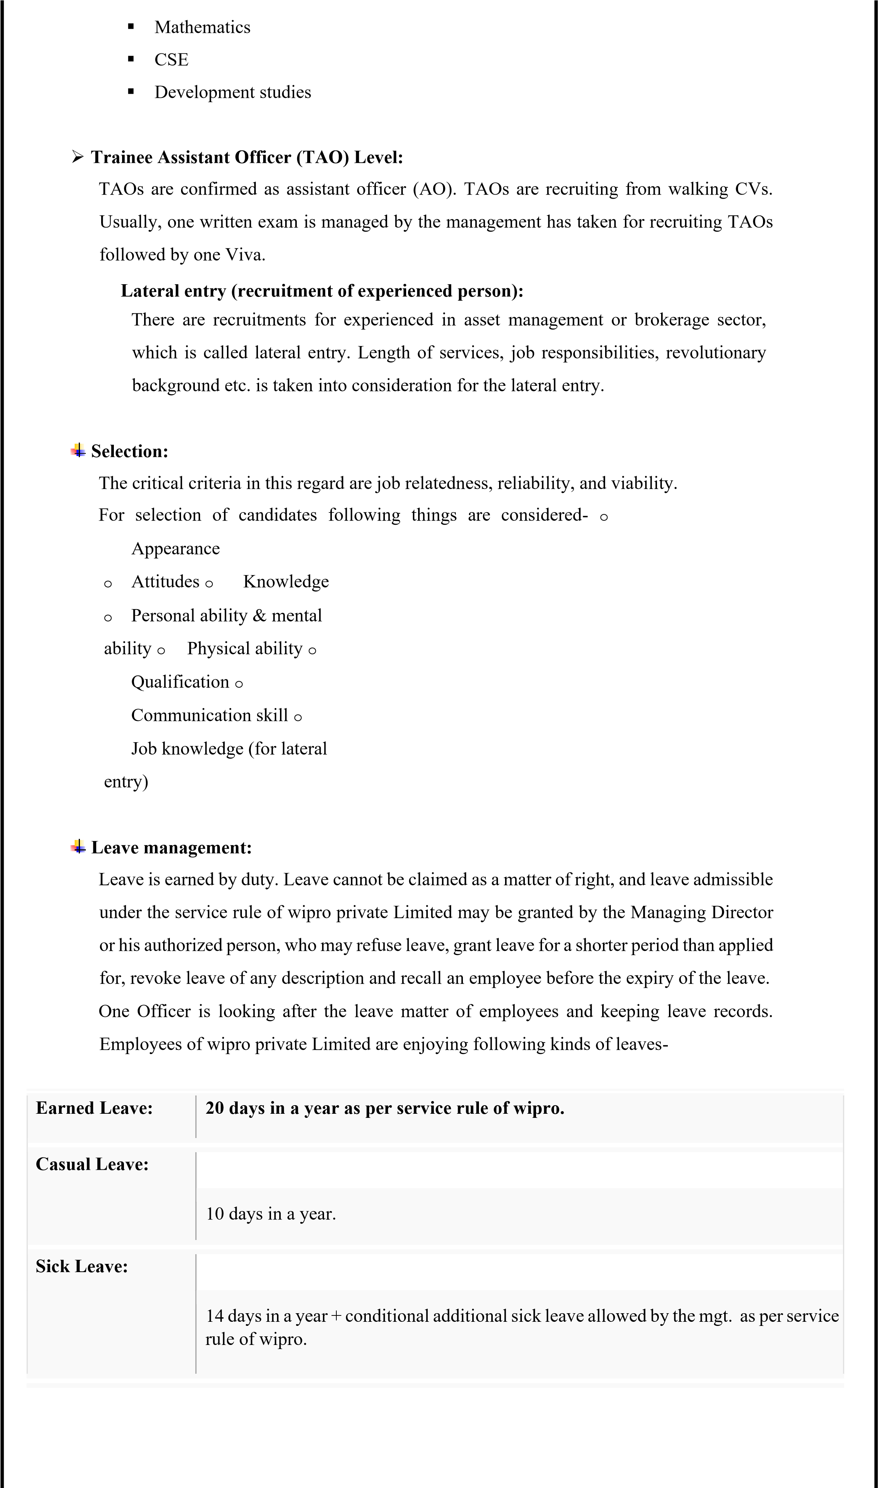

|  |  |
| --- | --- |
| **Maternity Leave:** | 24 weeks for each issue up to two children. |
|  |  |
| **LeaveWithout Pay** | 15 days once during the service life. |
|  |  |
| **Paternity Leave** | 5 days. |
|  |  |
| **Bereavement**  **Leave** | 5 days. |
|  |  |
| **Study Leave:** | As per the rule of the organization. |

**Personal Profile Management:** They maintain employees personal profile with hardcopy of documents for example: CV, NID, Educational Certificates and other necessary documents.

**4.1.2 HR Operations:**

HR operations unit mainly work in the area of short term and long-term benefits of the employees of ALLIANCE CAPITAL, like salary, bonus, provident fund, gratuity, super annulations fund, etc.

* Monthly Salary Disbursement
* Preparation and disbursement of Festival Bonus and Performance Bonus Employees Final Settlement.
* Maintain liaison with different AMC, which are under the corporate agreement with Alliance Capital Asset Management Ltd Limited.
* Submission of various Salary related MIS report to the Management & Regulatory bodies.
* Work as System Admin in HR department
* Assist in Appraisal Management
* Investment with the gratuity and PF fund Employee Tax processing, etc.

**4.1.3 Training & Development:**

Human Resource is the key to success of a service oriented business organization. The famous quotes from some renowned business leaders are:

* Take our 20 best people and virtually we become a mediocre company. o -Bill Gates, Chairman, Microsoft Corporation.
* Take my assets, leave my people and within 5 years I will have it all back. o -Alfred Sloan, Chairman, General Motors.

The mission of wipro private Limited is to be the premier financial institution in the country providing high quality products and services backed by latest technology and a team of highly motivated personnel to deliver Excellence in investment banking & Asset Management Company

**Steps of training program**

A typical training program can be classified into 5 steps

1. Need Analysis
2. Instruction Design
3. Validation
4. Implementation
5. Evaluation and Follow-up

**1. Need Analysis:**

* Identify the specific job performance skills needed to improve performance and productivity.
* Analyze the skills and needs of the prospective trainees and to develop specific measurable knowledge to perform their job.
* To ensure that the program will be suited to the trainees specific levels of education, experience and skills.
* Use study report to develop specific measurable knowledge and performance objective

* **Technique to identify Training Needs:**

Task analysis and performance analysis are two main techniques for identifying training needs.

* **Task analysis:**

The first step in training is to determine what training, if any, is required. The main task in assessing the training needs of new employees is to determine what the job entails and break it down into subtasks, each of which is then taught to the new employee.

So, task analysis is a detailed study of a job to identify skills required so that an appropriate training program may be instituted. Task Analysis form contains six types of information-

* Task list
* How often performed
* Quantity, Quality Standards
* Performance Conditions
* Skills Required
* Where best learned

* **Performance Analysis:**

Verifying that there is a performance deficiency and determining whether that deficiency should be rectified through training or some other means (such as transferring the employee).

1. **Instructional Design:**

Gather instructional objectives, methods, media, description of and sequence of content, examples, exercise and activities.

Make sure all materials such as video scripts, leader’s guides and participant’s workbooks, complement each other are written clearly and blend into unified training geared directly to the stated learning objectives.

Carefully and professionally handle all program elements-whether reproduced on paper, film or tape to guarantee and effectiveness.

1. **Validation:**

Introduce and validate the training program before it presented to the trainee.

1. **Implementation:**

When applicable boost success of training workshop focuses on presentation knowledge and skills in addition to training content.

1. **Evaluation and Follow-Up:**

Asses program success-according to-

**Reaction:** Document the learner’s immediate reactions to the training.

**Learning:** Use feedback devices or pre and post tests to measure what learners have actually learned.

**Behavior:** Note supervisor’s reactions to learner’s performance

following completion of the training. This is one way to the degree to which learners apply new skills and knowledge to their jobs.

**Results:** Determine the level of improvement in job performance and assess needed maintenance

**Setting training objective**

After training needs have been analyzed, concrete and measurable training objectives should be set. Objectives specify that what the trainee should be able to accomplish after successfully completing the training program.

**Techniques of training program:**

After determine employees training needs, set training objectives and designed the program, the training program can be implemented. Most popular training techniques are:

✓ On the job training ✓ Off the job training ➢ **On the job training:**

On the job training is like having a person learns a job by actually performing it. Virtually every employee, from mailroom clerk to company president gets some on the job training when he or she joined the firm.

A useful step by step job instruction approach for giving a new employee on the job training is as follows- o Preparation of learner o Presentation of the operation o Performance tryout o Follow-up

**On the job training has several advantages-** o It is relatively inexpensive o Trainees learn while they working o There is no need of class-room, programmed learning devices o Trainees learn actually doing the job o Get quick feed-back about the correctness of their performance.

**On the job management development techniques:**

On the job training is one of the most popular development methods.

Important techniques here include- o Job rotation o Coaching/ under-study approach o Junior boards o Action learning

➢ **Off the job training:** wipro do not provide off the job training.

Chapter: 5

Company Analysis

**5.1 SWOT Analysis:**

**STRENGTHS:**

The strengths of a company are the most important building blocks required for growth to take place. The following are a few of the most prevalent strengths that wipro private Limited has at the present time.

**Recruitment**: Their recruitment and selection policy is very strong. wipro private Limited recruits talented candidates from the market through proper testing- written and interview. The written part contains questionnaires that are of IBA standard which is a renowned education institution of our country.

**Work environment**: During my stay I found the work environment very satisfactory. Everyone is cordial and helpful and cooperative. There is less internal conflict or politics at play which is essential for conducting a productive working environment.

**Transparency**: For clear communication to the employees of the HR Practice in wipro private Limited, they have a service rule book which they give to every employee. The guide articulates important and covers all HR Practice followed by the organization. This is very helpful both for the employees and the employer as it removes chances of misinterpretation, bias etc.

**Leave Management**: They Provide a 44 days leave balance which include earn leave 20 days, Casual leave 10 days and Medical leave 14 days. So employees have no worries regarding having leave.

**Accountable Corporate Governance is very important for the AMC:**

Good Corporate Governance is an issue of vital importance to the Board and Management of wipro private Limited. The Board of Directors, as the head level of authority, is responsible and accountable for the overall direction and is ultimate answerable to regulatory authorities and shareholders for the activities, strategies and performance of the company.

The board now has 9 members, which also includes 2 independent directors. Alliance Capital board has a formal schedule of matters especially reserved for its decision including corporate strategy, approval of budgets and balance sheet, annual financial results, Director Appointment, proposal for dividend, approval of major corporate transactions and credit proposals beyond the delegated business power of the management.

**wipro private Limited** **provides online Services:**

wipro private Limited is among the few AMCs in Bengaluru, which provides the online services to its customers. By using the modern online services, where customer can purchase or repurchase an amount of shares of unit fund under its account. This service gives customer huge flexibility. More and more urban customers are becoming attracted to this service day by day. This online service provides great benefit for the customers, as they do not have to face the hassle of going to the office to know their balances.

**Training and development system of Wipro is a prime reason of their success:**

wipro private Limited gives regular training to the officer of both middle and lower levels. Again if there is any strategy or technology change, there will be special training program arranged based on individual needs. They arrange special training on their software also which they use in the office to operate their system, which eventually becomes beneficial not only for the employee but also for the organization, because if they do not know the exact procedure of carrying out work in their system then that might affect them both the employee end into making mistake, and as a result the reputation of the organization also might get hampered.

**WEAKNESS:**

Though wipro private Limited is a company that has many strengths but it also has some weakness.

The followings are few of the most common weakness that wipro has at the present time:

**Inadequate human resources:**

The human resources are not sufficient in terms of its service providing system. It has to maintain a number of formalities to recruit employees.

**Human Resource Planning:**

There is not much Human Resource Planning at the Organization except for an annual need assessment for required workforces

**Investors lack of knowledge about** **wipro private Limited:**

Open ended-mutual fund is a new concept in the capital market of Bengaluru. So, it’s new to the investors. They don’t have the idea how it works. Their concept about mutual funds is vague and they have a very pessimistic notion on the current negative performances of the closed-end mutual funds. The closed-end mutual funds are performing poorly for the couple of years and almost all are trading under their face value. **Fund is still small:**

Though wipro private Limited is managing the mutual fund of MTB but the fund size is still small.

Thus, investors have the negative idea about MTB Unit Fund.

**Lack of Job Analysis:**

It is the important part of HR practice in an organization but not implanted in wipro which means they are less informed about current market trends and that could lead to loss of potential talents from their pool.

**OPPORTUNITY:**

In an organization opportunities are positive external environmental factors. An organization should explore all possible opportunities available to it. These opportunities are intended to improve the organization. By making improvements, the organization should be able to become more competitive in the market. The following are available opportunities to Alliance Capital in order for it to become more aggressive:

**Recruitment:**

Most recruitment in here is through internal recruitment, they can spread the pool of entry level employees through campus recruitment.

**Recent performance will establish stronger credibility:**

The performance of Unit Fund in FY13-14 was strong. Their retained earnings hav

already provided a strong foundation for the portfolio. Because of the previous year performances investors are getting concern about the MTB Unit Fund.

**Expanded market:**

As new industries are coming into the market, capital market is being large enough and long term financial demand is being created. The open ended mutual fund is a new sector, so there are high possibilities of growth in this sector. Open ended mutual fund is a largely untapped market, and wipro will be able to capture a large number of institutional clients from competitors, as well as new clients.

**THREATS:**

An organization’s threats are negative external factors. An organization should explore all possible threats available to it. These threats are intended to diminish the organization. By making improvements and proper monitoring of the threats, the organization should be able to turn more competitive in the market. The following are threats are available to Alliance Capital Asset Management Ltd in order to threaten its existence.

**Volatile economy:**

The market can be volatile, and a sudden drop in prices will weaken client confidence & portfolio performance. Rise in interest rate and events like terrorist attacks are likely to affect the economy and the margin of leasing companies may also suffering this. The changing nature of share market also affect the smooth operation of MTB Unit Fund.

**Government Policy:**

The changes of policy connected to the operation of finance companies might create an unfavorable impact on the investment industry. The decision to withdraw the accounting practices accelerated depreciation and extra shift depreciation has decreased the profitability of the Mutual Funds.

**The Lack of Motivation of Employees:**

Sometimes the lack of motivation in employees can create a threat to the organization. Employees may be overburdened with tasks that are not their core-competencies. As a result, the quality and accuracy of deliverables duties may fall. Employee turnover may have a negative effect on the overall performance of organization.

Chapter: 6

Findings and Recommendations

**Findings of the study:**

* Compensation and Benefits: Compensation basically consists of direct and indirect compensation and Alliance Capital is very much concerned about both these types of compensation. They offer attractive package that is in per with current market practice in similar sector. They also offer bonuses and yearly incremental. For long term benefits, wipro has provision of Gratuity, Provident Fund. They also have leave planning for employees consisting of different kind of leaves according to employee needs.
* Performance Evaluation: The evaluation of employee’s performance of wipro private Limited is not properly done by the HR division.
* Officers of the organization are competent even though many of them simply know the working procedure of what they are doing but don’t know the philosophy behind doing those.
* Service quality of wipro private Limited is commendable. It is very important for every organization serve its customers so that it create a loyal customer base who will repeatedly buy its products and carry a long time relationship with the company as well as work as a spoken person to promote the products of the company to peers, friends, relatives, etc. This organization is really good at its service quality.

**Recommendations:**

* The organization should practice proper wipro private Limited guideline. The purpose of Human Resource Management is to improve the productive contribution of people.
* To get effective and efficient employee, the organization should arrange proper training and development programs.
* The entire HR department should be well informed regarding the employment personal.



The organization should provide well direct compensation as well as direct to its staffs.

* The management should have job evaluated salary structure, which is most competitive than other organizations in the country.
* To evaluate employee’s performance; the management should follow promotion policy properly.
* In order to get competitive advantage and to deliver quality service, top management should try to modify the services.
* Periodical performance appraisal and giving recognition and rewards to the qualified employees to keep motivating them.
* Proper training needed for ensuring efficient performance of the employees.
* wipro private Limited should hire specialist for each individual sector.
* The management should create customers database and continuously informing the investors about the available facilities or opportunities which will work to achieve twin goal at a time; one is direct marketing and another is large pool of customers database.

### Conclusion

From the above discussion it can conclude such a way that since human resource management is a continuously practicing issue so it plays a significant role on organizations overall performance. If an organization wants to gain full benefit from human resource management it should follow all the sections of HRM. As a small AMC few persons are recruited for its operations and performances. But it will expand soon or later and then the number of HR employee may not be enough to run the company.

Committed and trustworthy employees are the most significant factors to becoming an employer of choice, it is no surprise that companies and organizations face significant challenges in developing energized and engaged workforces. However, there is abundance of research to demonstrate that increased employee commitment and trust in leadership can positively impact the company’s bottom line. In fact, the true potential of an organization can only be realized when the productivity level of all individuals and teams are fully aligned, committed and energized to successfully accomplish the goals of the organization. Thus, the objective of every company should be to improve the desire of employees to stay in the relationship they have with the company.